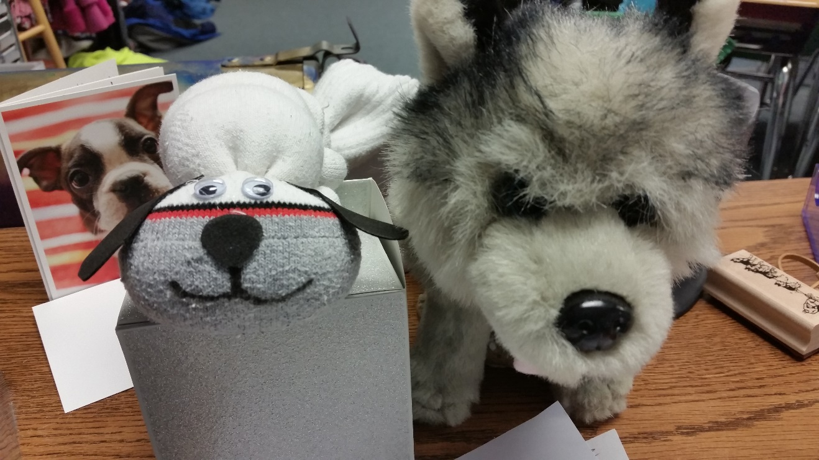WRITING AND READING INSPIRATION WITH SOCK PUPPIES!

After teaching about sled dog breeds and emphasizing how different they can look, students make their own husky sock puppy. Students choose which ears (pointed, folded, grey/brown/black) to put on their pups and create a unique Alaskan Husky. They may even choose to color their pups with markers and add a muzzle. The inspiration for these pups comes from Kim Slade, Iditarod Teacher 2007.

Students keep the puppies at their desks during the sled dog unit for reading and writing inspiration. I teach quotation marks/dialogue, story-telling, and “point of view” writing skills with these cuties. Students read to their pups during silent read. Even the most reluctant reader cannot resist sharing a story with their puppy friend.
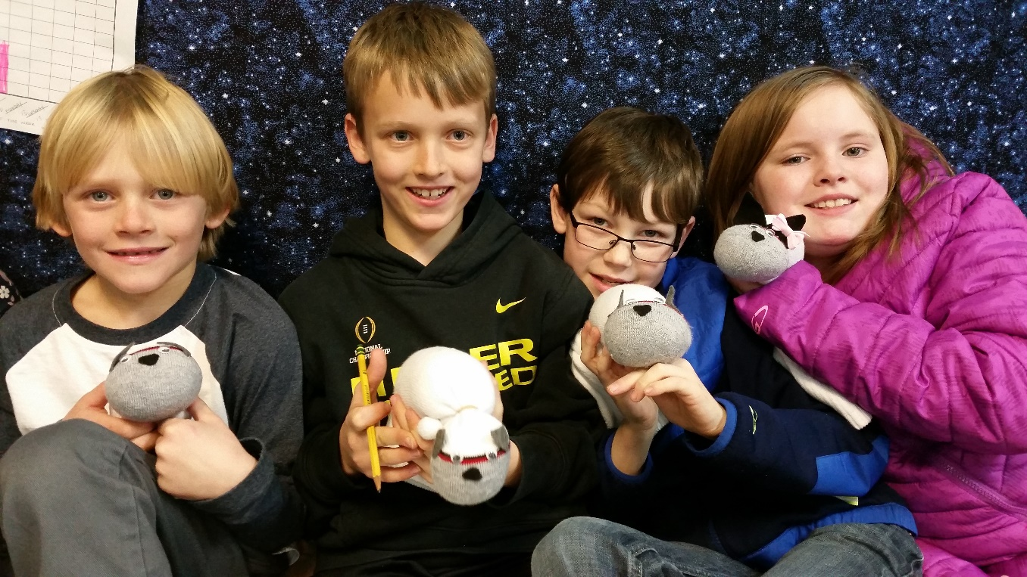

Here’s what to do:
First gather your materials:
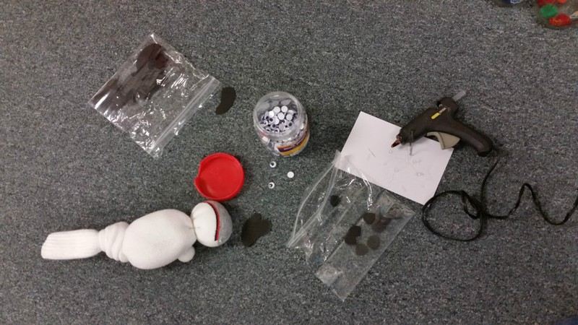
- 1 adult white tube sock per student
- 12-16 oz. rice per student
- rubber bands
- googly eyes
- felt for nose and ears glue gun
- markers

First, have students use a scale to measure about a pound of rice. This activity can be used to teach estimation and measurement skills. After filling the sock with 12-16 oz of rice, tie a knot at the end. Using rubber bands, make a head, and 4 small ball feet. Use a glue gun to adhere googly eyes, nose and ears to head. Kids can decorate with markers as needed.

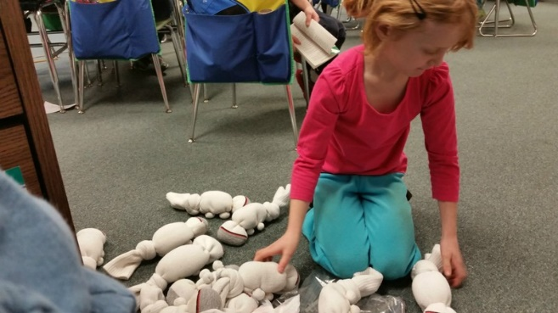
Next, kids choose a puppy from the "litter" to decorate and create their own unique faces. Some choose the runt, others the fattest puppy found. It's fun to see the individual choices.

Next, the students name their pups and start a lesson.

Here are a few writing ideas:
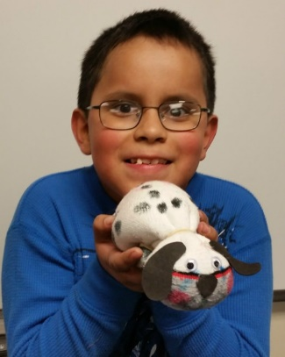
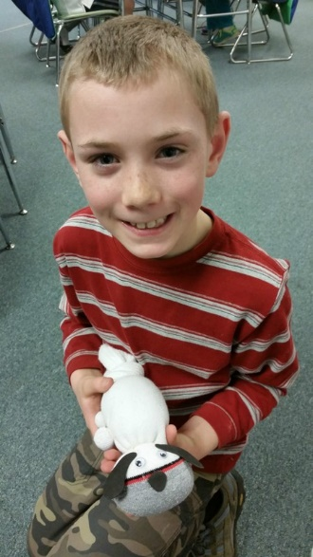
Mushers tend to name their litters thematically. You may choose a theme for your classroom, and have students come up with names that fit. For example, our class is the Wildflower litter. Pups names include Daisy, Thistle, Dandy (Dandelion), etc.

- What is the theme of this litter and what is the name of your pup? What could other names be for the pups?
- Why did you choose the pup you did?
- From your pup's point of view, what is life like?
- What do dogs need to grow and thrive?
- Write a point of view piece: A day in the life of ____.
- Set some goals for your pup to run the ESSSDR one day. What do they need to achieve their goals?
- Have two or more pups talk to each other using dialogue (Quotation marks) embedded in their writing.

